Temasek Polytechnic

School of Informatics and IT

**Diploma in Information Technology (IT)**

Software Requirement Specifications (SRS)

**Project Particulars**

|  |  |
| --- | --- |
| **Tutor** | Mr Mel Goh |
| **Class** | P02 |
| **Project Title** | Delonix Regia Hotel Management System |

**Project Team’s Particulars**

|  |  |
| --- | --- |
| **Matric Number** | **Student Name** |
| 1500564H | Shawn Yang |
| 1502728G | Xavier See |
| 1500340C | Yeo Kai Sheng |
| 1500858D | Yeo Ai Ling |

Revision History

|  |  |  |  |
| --- | --- | --- | --- |
| **Date** | **Version** | **Description** | **Author** |
| 14/05/2017 | 1.0 | Distribution of Workload  System Functions  User Characteristics | Shawn |
| 15/05/2017 | 1.1 | System Functions  User Characteristics | Shawn |
| 16/05/2017 | 1.2 | Distribution of Workload | Xavier |
| 16/05/2017 | 1.3 | Operating Environment  Development Constraints | Shawn |
| 17/05/2017 | 1.4 | System Functions  User Characteristics  Operating Environment  Development Constraints | Shawn |
| 17/05/2017 | 1.5 | Data Requirements | Ai Ling |
| 19/05/2017 | 1.6 | General Constraints  Functional Requirements | Xavier |
| 20/05/2017 | 1.7 | Performance  General Constraints  Special Requirements | Xavier |
|  |  |  |  |
| 21/05/2017 | 1.8 | References | Shawn  Xavier |
| 23/05/2017 | 1.9 | Functional Requirements | Xavier |
| 23/05/2017 | 2.0 | Functional Requirements  Performance | Shawn |

**Table of Contents**

**DISTRIBUTION OF WORKLOAD** **4**

**OVERVIEW OF REQUIREMENTS** **5**

System Functions (Shawn) 5

User Characteristics (Shawn) 9

General Constraints 9

Functional Requirements 11

Data Requirements 15

User Interface Requirements 16

Interface with Other Systems 23

Assumptions 25

**OPERATIONAL AND QUALITY REQUIREMENTS** **25**

Operating Environment (Operating System) (Shawn) 25

Development Constraints (Shawn) 33

Performance 34

Availability 35

Security and Access Control Requirements 36

**SPECIAL REQUIREMENTS** **37**

**REFERENCES** **39**

# DISTRIBUTION OF WORKLOAD

*[Determine which members of the team will be responsible for which areas in the requirement gathering process. Individual’s responsibilities should be clearly spelt out.]*

|  |  |
| --- | --- |
| **Requirement Gathering** | **Members** |
| System Functions  User Characteristics  Operating Environment  Development Constraints | Shawn |
| General Constraints  Functional Requirements  Performance  Special Requirements | Xavier |
| Data Requirements  User Interface Requirements  Availability | Kai Sheng |
| Interface with Other Systems  Assumptions  Security and Access Control Requirement | Ai Ling |

# 

# OVERVIEW OF REQUIREMENTS

## System Functions (Shawn)

*[List and give a brief description of the functions of the systems that are to be implemented.]*

* **Room availability & Booking Module**

This module is basically a hotel room reservation & room booking system that would be used as part of the Delonix Regia Hotel Management System.

More than 70% of hotel reservations are made online, hence this booking engine is to allow customers to book a hotel room through their devices instead of travelling down to the location to book. In order to book online, customer would have to provide the following details:

Customer Contact Details:

* First Name
* Last Name
* Number of adults
* Number of children
* Phone Number
* Email
* Home & Mailing Address
  + Street Address
  + Block Address
  + House Number
  + Postal Code
  + Country

Payment Details:

* Cash Payment
* Credit Card Payment
  + Credit Card Number
  + Credit Card Holder’s Name
  + Expiration Date
* Check In & Check Out Details
  + Date
  + Time
* Additional Remarks (Whether the guest wants king size bed or queen size bed or smoking or non smoking room etc)

A summary of the details entered by the customers will be shown and then submit to the management system once the customer confirms the information shown in the summary The hotel management system would then respond to the online reservations request by sending a computer generated email to inform customers whether there are rooms available to accommodate them. If there are not enough rooms to accommodate customer's request the hotel management system would send email to customers to notify them and recommend that they should amend their reservations request or cancel it.

For walk-in customer they will make their reservation with the person in the customer service desk. They will be in charge of taking down the customer’s details. Just like online booking, the customers would be asked to fill up the following details:

Customer Contact Details:

* First Name
* Last Name
* Number of adults
* Number of children
* Phone Number
* Email
* Home & Mailing Address
  + Street Address
  + Block Address
  + House Number
  + Postal Code
  + Country

Payment Details:

* Cash Payment
* Credit Card Payment
  + Credit Card Number
  + Credit Card Holder’s Name
  + Expiration Date
* Check In & Check Out Details
  + Date
  + Time
* Additional Remarks (Whether the guest wants king size bed or queen size bed or smoking or non smoking room etc)
* Indication as to whether the guest is asking for a late check out

A summary of the details entered by the customers will be shown and then submit to the management system once the customer confirms the information shown by the staff. The person at the customer service desk would check with the hotel management system whether there are rooms available to accommodate them. The person at the customer service desk would then inform customers of room availability. If there are not enough rooms to accommodate customers, the person at the customer service desk would recommend customers to amend their reservations or cancel their reservations.

* Housekeeping & Staff Management Module

Using the Housekeeping & Staff Management Module, the hotel manager would be able to track rooms that need cleaning before guest arrive, or even track the number of rooms that are cleaned on a given day so that the staff who have the duties of performing the housekeeping work would be able to work efficiently as they would be able to know accurately when is their housekeeping shift and which level rooms are they supposed to perform their housekeeping duties at.

Using the Housekeeping & Staff Management Module, the hotel manager would also be able to manage and update the staff work schedule and their respective roles so that it would improve staff performance and efficiency in the four walls of the hotel and the management of the staff would be well coordinated. The manager would also be able to manage staffs’ monthly salaries accordingly and provide with their salaries on the appropriate pay day.

It has 2 key features:

* To let the Hotel Administrator keep records of the staff like the staff name, date of birth, bank account number, home address, phone number, duty types
* Duty Types (General Maintenance, Room Maintenance, Estate Maintenance, Security)

General Maintenance

General Maintenance refers to the general maintenance work in the hotel such as attending to hotel guest request of all sorts, inspecting hotel areas daily for any issues, inspection and cleaning of hotel equipment and keeping the hotel neat and tidy.

Room Maintenance

Hotel Room Maintenance refers to the regular maintenance of hotel rooms such as the maintaining room cleanliness, room neatness, check that air conditioners are clean, check that all furniture in the rooms and replacing or fixing any that are broken.

Estate Maintenance

Estate Maintenance refers to the maintaining of the hotel facilities such as the hotel lobby, elevators, fitness centers, pool, toilets and concierge and etc. The hotel staff are expected to maintain the facilities by fixing any broken door handles, broken railings, remove stained carpets, clean toilets and remove dirty furniture and etc.

Security

Hotel security is paramount for any hotel especially regarding the security of the guest and staff in the hotel. A solution to maintain hotel security is to control access to various parts of the hotel that should only be accessible to authorised personnel only. This practice would prevent money and guest valuables from being stolen especially from guest rooms as staff would carefully handle guest room keys that would not fall into the wrong hands and only authorised guest can access their rooms.

We have 5 Reports in the reports module

* Room Status Report

This report which is the Room Status Report will list all the rooms in the hotel and their respective room status. There are three room status which are whether the room is vacant or not, whether the room is occupied and whether the room is vacant and has been scheduled for cleaning by the hotel staff.

* List all the guest in 1 particular room report,

This report which is the list all the guest in 1 particular room report when generated, the hotel administrator which is Mr Wang or other administrative staff would be able to see all the occupants in the particular room.

* List all the guest in all the rooms at any given time report

This report which is the list all the guest in all the rooms at any given time report. The hotel administrative staff would be able to list all the guest staying in all the rooms let say on 20th january this year or at another certain date.

* Room Occupancy Report

The Occupancy Report which will be used for management purposes. The report will generate statistics that will indicate what was the room occupancy on a daily, weekly, monthly and yearly period. This report should only be available to management and administrator users.

* Housekeeping Report

This report will list the duties that the staff have been allocated to which are general maintenance, room maintenance, estate maintenance and security. This report should allow Mr Wang and administrative users to generate the housekeeping schedule based on a daily, weekly and monthly basis and this report should only be available to the management users and the administrative users.

Reporting Module Additional Feature

For Mr Wang and administrative users to be able to preview the report before Mr Wang send it to the printer, this would definitely be a useful feature.

## User Characteristics (Shawn)

*[Describe the characteristics of the users of the systems and the role they play.]*

Users

3 Level of users

End Users

The first level of users are the end users who are the reception staff at the front counter in the hotel and these receptionist are to access the various selected reports of the reporting module and they would also need to have full access to the room availability and booking module so that they can serve customer needs at the front counter such as helping customers to make a booking or access the number of rooms available that can accommodate customers.

Management Staff

Management users are users who will have full access to the 3 modules which are room availability & booking module, housekeeping & staff management module and the reporting module. The hotel management staff would be presumably the hotel manager who would be in charge of the staff rosters and duty shifts.

Hotel Administrator

The hotel administrator which would be Mr Wang and he would have all access to the 3 modules which are room availability & booking module, housekeeping & staff management module and the reporting module and in addition, he will also have access to a user's account and login creation module to create new accounts for new staff and new users as well.

## General Constraints

*[Highlight any constraints such as dependency on other systems, existing hardware/software platform or technology, restriction due to organization policy or legal requirements.]*

Budget

* Mr Wang has specified 4 months ago, with Mr Lim of Pantheon Systems, that the final budget will be $70,000. With this budget, it would mean more constraint on the design and process as it may limit hardware and software purchases. Without the proper hardware or software it may decrease work efficiency and end up slowing down the entire project – leading to being unable to meet the deadlines.
* Budgets are known to be inaccurate estimations of spending. We would have to make sure that the hardware or software purchased is not too expensive nor is it too cheap to the point where it is not useful at all. This can lead to a constraint on time as we would need to spend time researching on the right hardware and software to purchase. Budgets would also cause more wary of purchases which may sometimes lead to inefficient hardware or software.

Dependency

* Mr Wang is currently using one computer located at the staff reception area. It is a Pentium 4 PC running on Windows XP support package 2. It uses 1GB RAM, 160GB Hard disk, and is connected to internet parlor broadband connections. As Windows XP support has ended, the system may also be exposed to all kinds of security issues. This will lead to the need of developing the software with higher security which may require more research, time and money.
* The designed system must be able to be supported by Mr Wang’s computer or it may end up with lower performance and lag issues.
* Lack of the necessary hardware and software tools will lead to slow development or even not being able to develop the system at all.

Time

* Time constraints while developing the software due to family businesses e.g. Religion purposes, Funeral.
* Other assignment/work slowing work process
* Unable to attend meetings and collaborations due to co-curricular activities
* Schedules may not be the same which may result in only some members meeting up to discuss

## Functional Requirements

*[Function requirements state what the system should do e.g. the system shall allow library items to be search by Keywords, Author, Title, and Call Number.]*

Room Availability and Booking Module

* All features must be made accessible to Reception staff, Management users, and Administrators (Mr Wang) to use for booking a room or checking the room availability for customers.
* Module must allow staffs to be able to enter customer’s information and check if the room is vacant or currently occupied.
* Module should allow rooms to be searched by the type of room.
* Module should be able to accept data inputs such as:
  + Customer’s information
    - First name and Last name
    - Number of adult guests and children staying in the room
    - Contact details
* Phone number
* Email address
* Home mailing address
* Street address
* Block/House number
* Postal code
* Country
* Payment Details
* Cash payment
* Credit card payment
* Credit card number
* Credit card holder name
* Expiry date
* Check-in details
* Check-in date and time
* Desired check-out date and time
* Additional remarks e.g. king size or queen size bed, smoking or non-smoking rooms
* Indication as to guests requesting for late checkout
* Module should be able to generate a payment invoice when they checkout which should include:
* The calculated number of days stayed
* The items consumed from the mini-bar
* Guest details such as check in and check out dates
* Number of nights the guest stayed
* Room rates
* Any additional cost
* Module should allow Mr Wang and the Reception staff edit guest records as and when they actually come in. All details of guest should be changeable.

Housekeeping and Staff Management Module

* All features should be made accessible to Management users and Administrators (Mr Wang) for managing housekeeping and staff schedules as well as their details.
* Module should allow the staff schedules and staffs to be searched by duty types and staff name
* Module should allow Administrators (Mr Wang) and Management users to assign duties to housekeeping staffs. The duty types include
  + General Maintenance
  + Room Maintenance
  + Estate Maintenance
  + Security
* Module should allow Administrators (Mr Wang) to keep records of all details of his staffs which include:
  + Staff name
  + Date of Birth
  + Bank account number
  + Contact details
    - Phone number
    - Home address
* Street address
* Block/House number
* Postal code
* Country
* Duty Types

Reporting Module

* All features should be made accessible to Management users and Administrators (Mr Wang), only parts of the features are made accessible to End users such as the reception staff; Room Status, Guest Status, and Listing all the guests in all the rooms at any given point.
* Reporting Module should allow its reports to be searched by the report type, report ID, report name
* Reporting module should allow Room Status report to be created where it lists all the rooms that is in the hotel and their respective room status:
  + Available (vacant)
  + Is it currently occupied
  + Vacant and scheduled for cleaning
* Reporting module should allow Guest Status report to be created where it lists all the occupants in the room e.g. two adults and three children are in the room
* Reporting module should be able to list all the guests in all the rooms at any given point in time. For example, the report should be able to list all the guests staying in all the room during 24th January this year.
* Reporting module should be able to create a Room Occupancy report and Housekeeping report for management and administration purposes.
  + Room Occupancy Report – It should be able to generate statistics indicating what the room occupancy was on the daily, weekly, monthly, yearly period.
  + Housekeeping Report – It should be able to list duties of staff that was allocated and also generates housekeeping schedule on the daily, weekly, monthly basis.
* Reporting module should allow users to preview the reports before deciding to send it to the printer

User account and Login Creation Module

* Administrators (Mr Wang) must be able to create new accounts for new staffs and new users

Additional Feature: Online Booking Module

* Administrators (Mr Wang), Management users and Receptionist should able to manage online user bookings made on the online hotel booking module as the staff would able to view booking information such as who made the booking, booking cost, number of persons per room, payment mode and user contact information.

## Data Requirements

Listing all the guest in all the rooms

* Guest Name
* Room
* Type of Room
* Check in Date
* Check out Date

Housekeeping report

* Staff Name
* Duty types
* Date
* Time

Room occupancy report

* Room number
* Occupants
* Number of adults
* Number of children

Guest status

* Guest’s Name
* Guest Room number
* Occupancy
* Check in date
* Check out date

Room status

* Room Number
* Room type
* Status

Staff Management

* Staff Name
* Date of birth
* Bank account number
* Address
* Phone
* Duty types

Room List

* Name
* Room number
* Room type

Booking information

* First Name
* Last Name
* Occupancy (Number of Adults, number of Children)
* Phone
* E-mail
* Address
* Payment Details
* Check in date and time
* Check out date and time
* Additional Remarks

## User Interface Requirements

*[Describe any user interface diagram or draft screen shot drawn out during the requirements gathering process. You may also describe the navigation mechanism if necessary.]*

Login

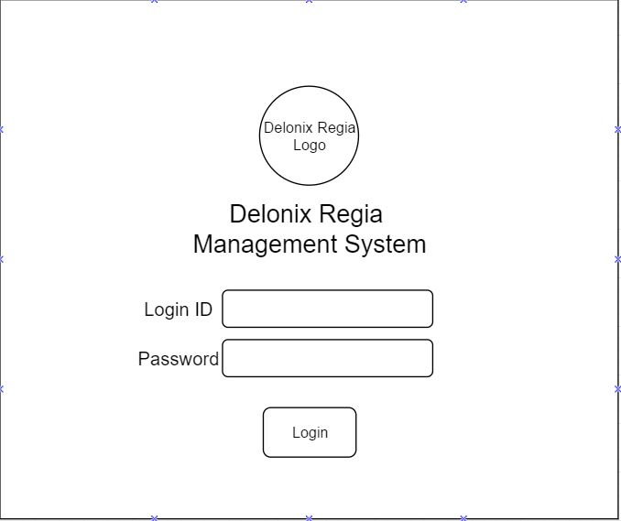

This the login screen of the Delonix Regia Management System which is only accessible by staffs of Delonix Regia Hotel. It also acts as a form of security to make sure no outsider or hackers are able to bypass the system.

**Room Availability and Booking module**

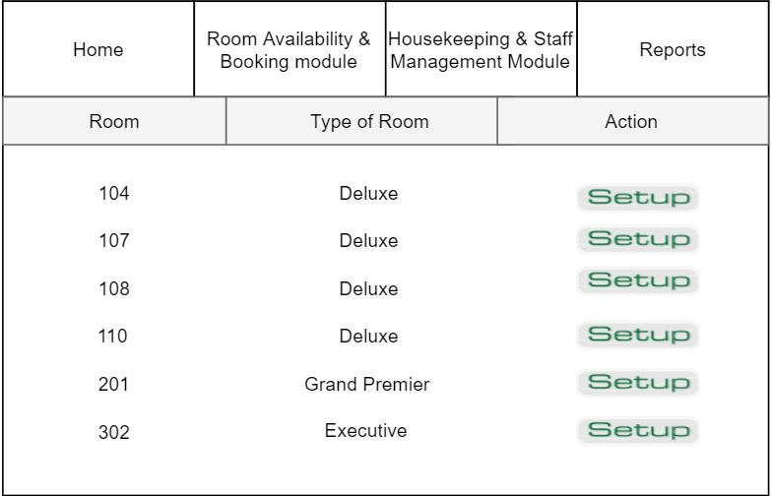

This is the room availability page which will display all the room numbers and type of room that are vacant.

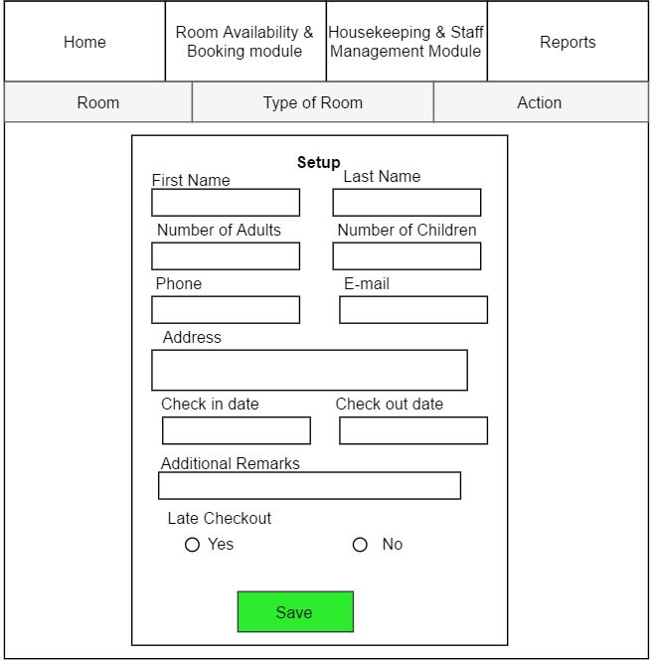

If the receptionist chooses a room the setup, a pop-up window will appear displaying all the customer’s necessary information to be key down.

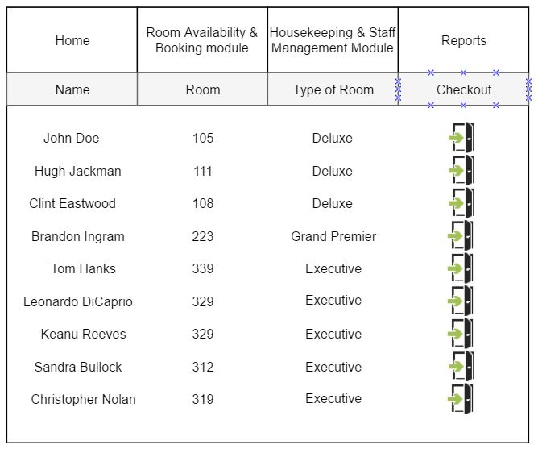

Once setup is complete and the customer’s information has been saved, his or her information can be seen in the Room List page. This also provides a checkout button if customers have checkout and the room is no longer occupied.

**Housekeeping & Staff Management Module**

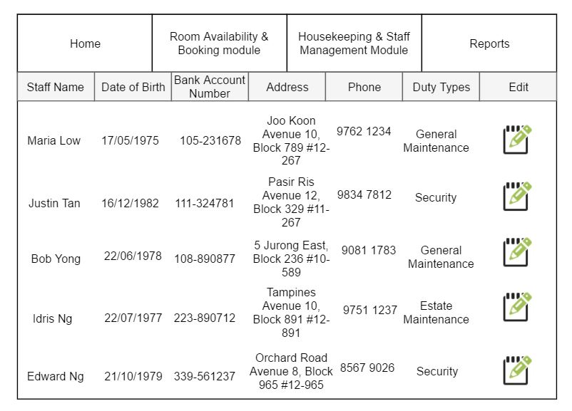

This module page allows Mr wang as well as the management users to see information of each staff and which duty type they are allocated to. As such, they can also edit any information of an individual staff.

**Reports**

Room status page

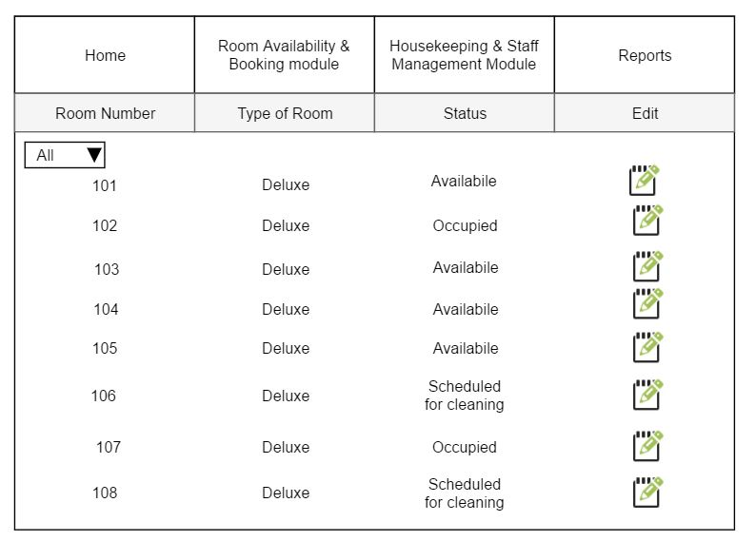

The room status page records all rooms that is in the hotel and their respective room status - available(vacant), occupied and scheduled for cleaning.

Guest status page

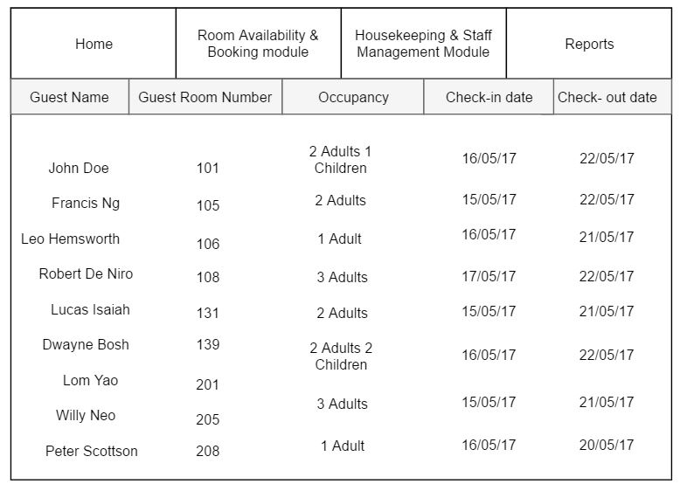

The guest status page lists the total occupancy in the room. For example, in Room 101, there is a total occupancy of 2 adults and 1 children. It also shows the room number is occupied by which guest.

Listing all guest in all rooms page

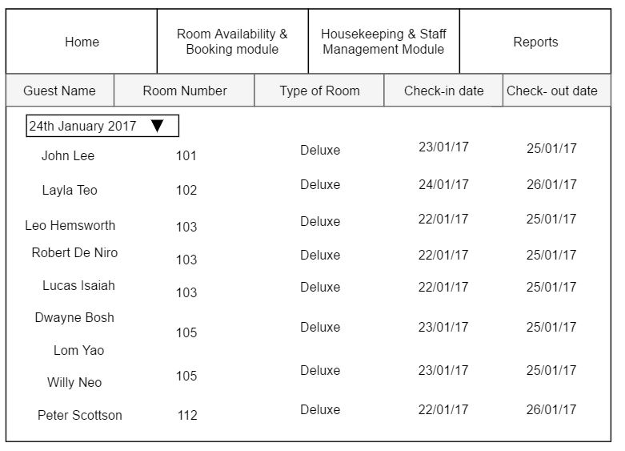

This page helps to provide the information of all the guest that have stayed a particular day.

For example, based on the image shown, it displays the guest name, room number and type of room of each guest on 24th january 2017, anywhere between the check-in and check-out date, so long as the room is still occupied during that day

Room occupancy report page

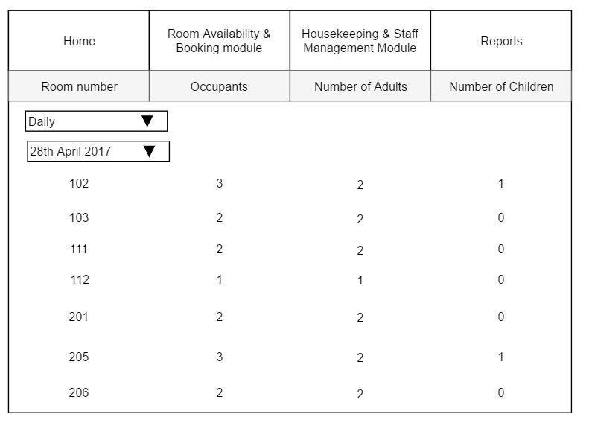

This report generate the statistics indicating the room occupancy on the daily,weekly,monthly and yearly period. it is used for management and administration use.

Housekeeping report page

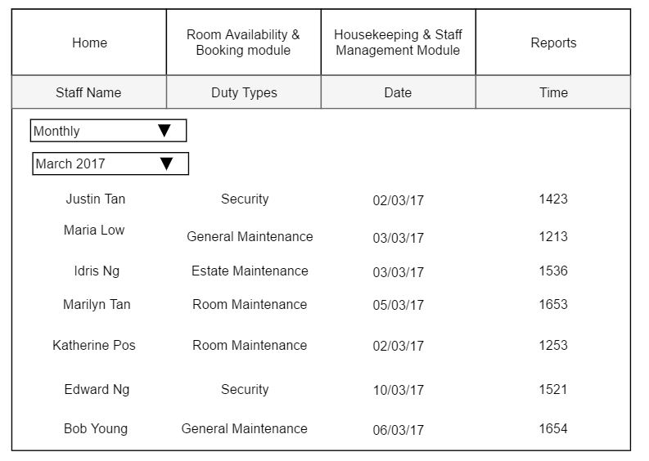

The housekeeping report helps to record the duties of staff that was allocated and generate housekeeping schedule on daily, weekly and monthly period.

## Interface with Other Systems

*[Describe any requirements to interface with other system, either new or existing. List any specification for interfacing and the required data format for communication between the systems. Include any security considerations for such data transfer.]*

**Peripheral Hardware**

It is a computer device that is not part of the essential computer. These auxiliary devices are intended to be connected to the computer and used. In this case, we will be looking at one specific type, which is the printer. It is relevant in this context as hardcopy information will be needed from time to time such as Payment receipts. Tasks are to be sent to the printer before the documents can get printed. For this to happen, the printer has to be configured to the network that the system’s interface is on.

*Security Requirements*

Unless the printer administrator re-configures the printer, it will be affected to remote intruders where they are able to get full access to the data that is being sent to the printer. Therefore, it is vital that a hardware device like this complies with the following:

o *Application of Manufacturer Firmware*

It is essential to review the manufacturer's recommendations when it comes to secure printer configuration. There are usually manufacturer firmware updates which should be executed to achieve the goal of device security. Other necessary configuration changes should be made as well; It includes the access control/firewall.

o *Passwords*

Whenever there is a need of remote devices to be connected to the printer, the strength of a password is greatly important. A strong password would be one which contains numbers, symbols, capital letters and lowercase letters.

o *Restrict Access*

Unused remote access services & protocols should be removed to prevent third party intrusion.

## Assumptions

*[Record any assumption made or implied regarding the requirements you have gathered for the system.]*

It is assumed that the hotel is a small hotel, with not more than 6 level, and for each level, there is only a maximum of 4 rooms. It is assumed this way as there will only have one computer at the reception counter to manage the whole hotel system. Thus, if the hotel is too big for only one computer to process all these guests’ requests at the same time, it will either crash or lag very badly. Thus, the team have assumed it to be a small sized hotel where only 1 computer is able to manage all the requests.

# OPERATIONAL AND QUALITY REQUIREMENTS

## Operating Environment (Operating System) (Shawn)

*[Describe the actual operating environment that the system will be deployed.]*

Delonix Regia Hotel Management System by its name will be deployed and operated in the Delonix Regia Hotel setting. The system software will be installed in a single computer in the receptionist staff area in the four walls of the hotel. It is the only location in the hotel where the software is going to be installed. The computer that is being used is a fairly old computer.

It is a Pentium IV Desktop Personal Computer that is running on a Windows XP support package two. The computer uses a 1 GB RAM, 160 Gigabytes of Hard Disk space and it is connected to the Internet via a broadband connection. The computer is situated in the same location in the hotel where Mr Wang setup and maintained the Blog site for the hotel.

Considering the operating system used by Mr Wang in the computer at the receptionist staff area is a legacy system in which it has been in use for a number of years and it is outdated, we would like to propose 2 new systems and the use of a new computer system for the Delonix Regia Hotel Management which are Windows 10 OS, MySQL Workbench database system and HP Pavilion 24-A251D i5 W10 All in One Desktop PC.

**Windows 10 OS Features:**

* Features a scrolling Start Menu that's restricted to a single column with jump lists, fly out menus and divided into commonly used and recently installed programs.
* Features a redesigned task switcher with bigger thumbnails and the task view icon is located in the taskbar
* Features an action centre featuring as an action centre which provides users of Windows 10 OS with notifications.
* Features an enhanced command prompt which is allowed to be resized and users are allowed to use common keyboard shortcuts to copy and paste on the command prompt.
* Features an enhanced Window’s Explorer which is a file explorer that contains a new ‘Home’ view that would display to users, a new Quick Access list of useful locations and folders and enhanced Share tab.
* Features a new Microsoft browser called Edge Browser that is a leaner and fast performing browser.

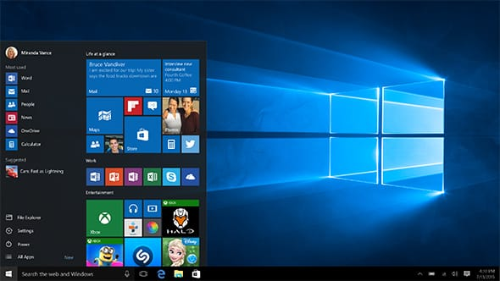

(Image Source: <https://dri1.img.digitalrivercontent.net/Storefront/Company/msintl/images/English/en-INTL-Windows-10-Home-KW9-00265/en-INTL-L-Windows-10-Home-KW9-00265-RM1-mnco.jpg> )

**MySQL Workbench database system**

MySQL Workbench is a visual tool for database activity and development for software developers, database architects and etc. MySQL Workbench enables database modelling, use of database relational schemas, use of SQL statements, use of user administration database and etc.

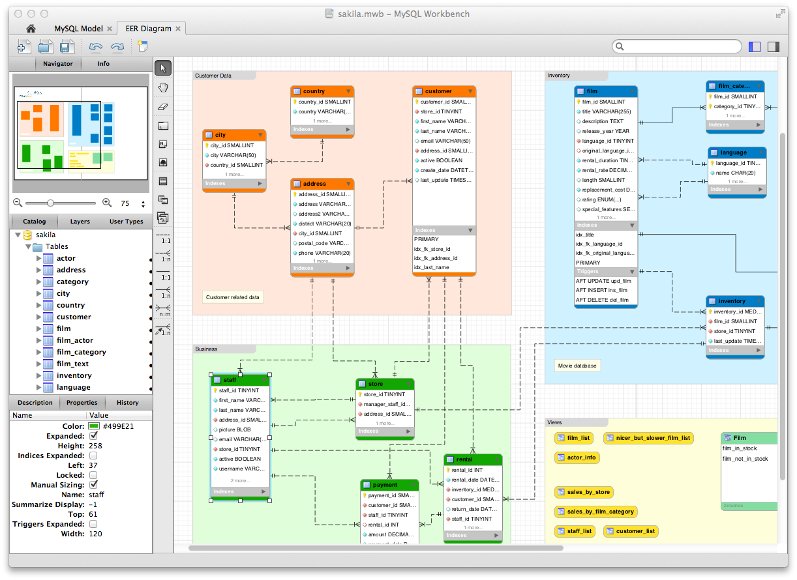

(Image Source: <https://www.mysql.com/common/images/products/MySQL_Workbench_Visual_Design_Mac.png> )

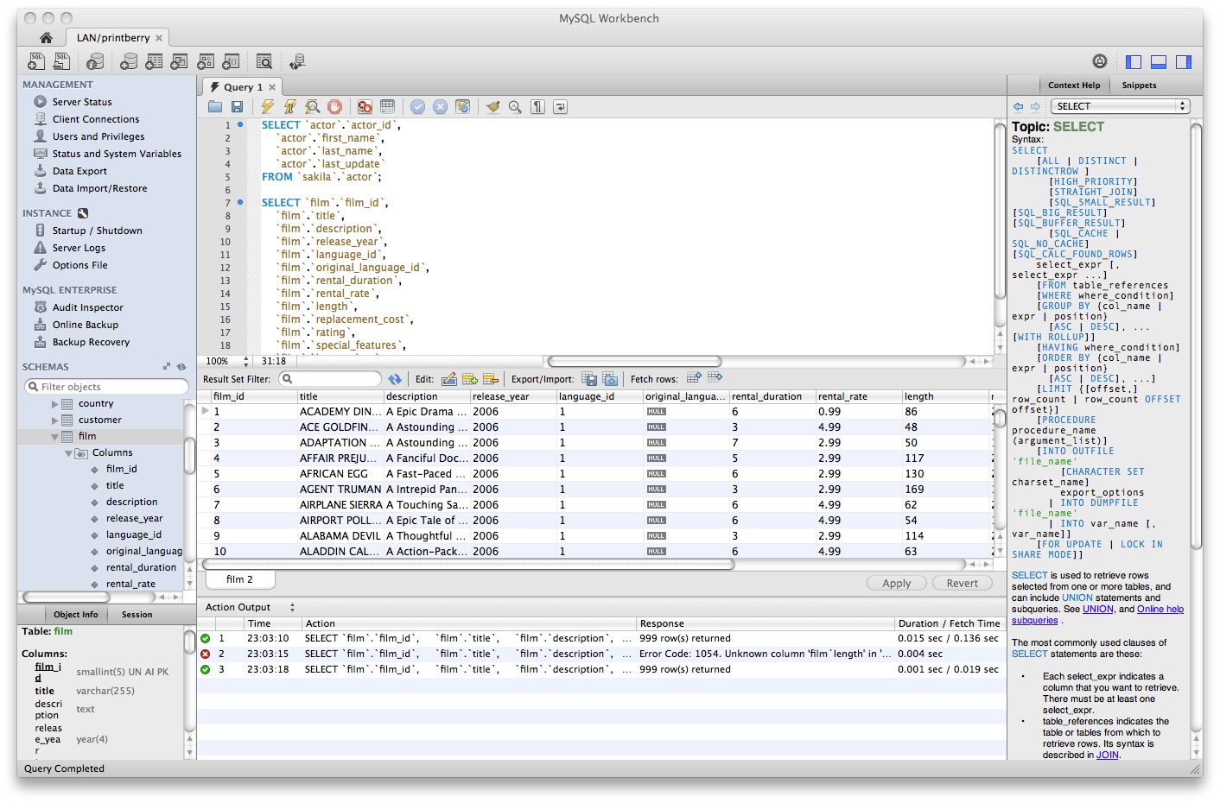

(Image Source: <https://www.mysql.com/common/images/products/MySQL_Workbench_Editor_General_Mac.png> )

**Features:**

* SQL Editor

Used for writing, running and debugging of SQL written statements

* SQL Syntax Highlighting

Used for colour highlighting of the SQL code syntax

* SQL History

Features the use of running the SQL program history of all executed SQL syntax

* Server Stop/Start

Features the stop & start of SQL servers locally and remotely

* Server Configuration

This feature enables the MySQL server settings to be viewed and changed

* Application Roles

Features the quick grouping of privileges for users

* User Management

Features the use of 5 basic functions when maintaining MySQL users and privileges which are view, edit, create, delete and clone

* Object Browser

Enables simple navigation, exploration, and execution of actions on database objects (tables, views, triggers, and etc)

**Visual Database Schema Design**

MySQL Workbench make it simple for database design and database maintenance. It also automates time-consuming and various prone to error task and will enable Mr Wang and his business to improve interaction and communication with his various stakeholders. It will also enable our project team to resolve any design faults before a major investment of resources has been made.

MySQL Workbench also enables relational database schema designs to be efficiently and automatically model driven which is the most successful method for the creation of a acceptable and efficient database.

**Visual SQL Editor**

MySQL Workbench would enable our project team to build, edit and run SQL query statements, create and edit data, view and export data to another place like another database schema. Colour highlighting of the SQL code syntax, context sensitive support and automated completion of aids in writing and debugging SQL statements. The SQL Editor has the following features:

* Table Editor

Features simple editing of data and changes committed to using a simple grid by grid format

* Results Window

This feature enables the execution of various SQL query statements simultaneously and the viewing of results of the running of the program, image spatial views, SQL query statement performance stats on specific SQL database tabs

* Export Results

Features the exporting of results data of SQL query statements execution to known formats such as HTML and XML

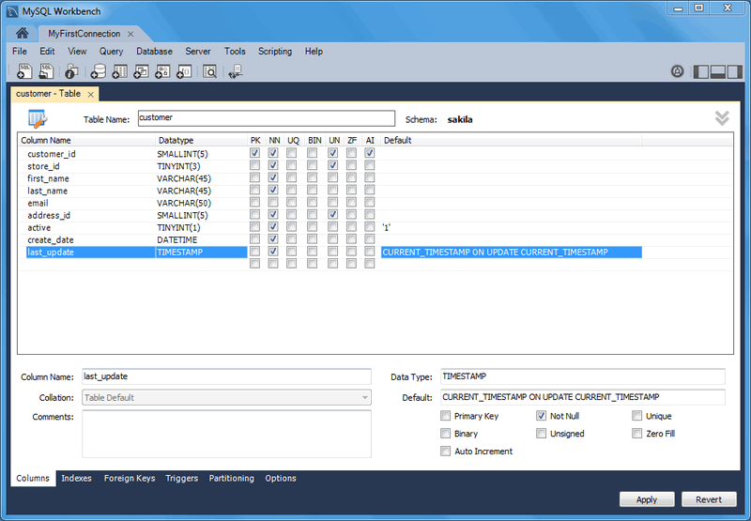

(Image Source: <https://dev.mysql.com/doc/workbench/en/images/wb-table-editor-columns-tab.png> )

**Object Management**

MySQL Workbench also provides an Object Browser which would enable our project team to simply navigate the relational database schemas. We would be able to select tables, specific cells, rows and columns when using the relational database schemas. We would also be able to edit the tables, create new tables and relational schemas, and drop tables and relational schemas.

* Object Browser

Enables simple navigation, exploration, and execution of actions on database objects (tables, views, triggers, and etc)

* Object Editor

Enables simple changes to objects, allows for the creation and deletion of relational schema objects like tables, views, triggers and etc.

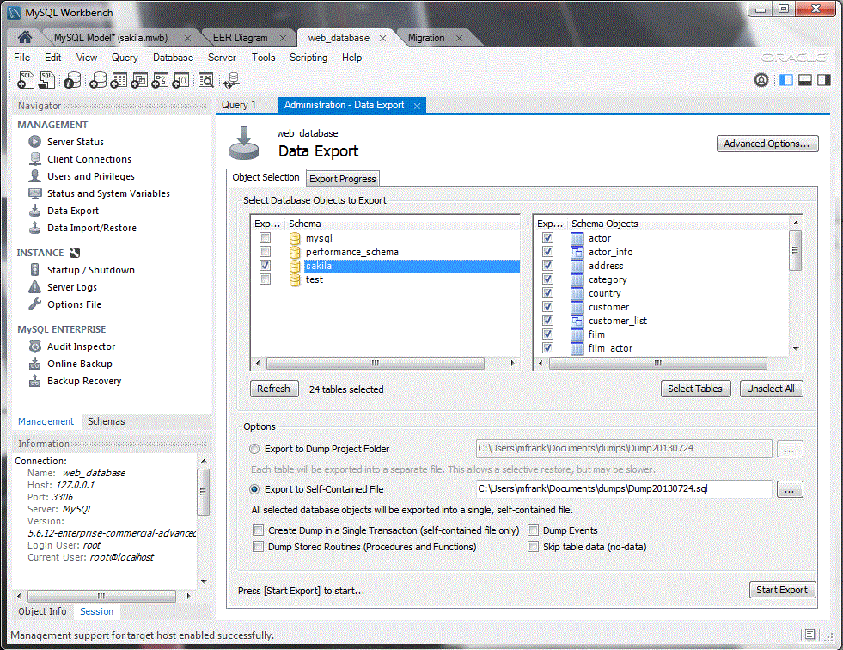

(Image Source: <https://www.mysql.com/common/images/products/MySQL_Workbench_Admin_ExpImp_Windows.gif> )

**HP Pavilion 24-A251D i5 W10 All In One Desktop PC**

This Desktop PC is update in terms of operating system, it also contains high performance system specifications and it is the best replacement for Mr Wang’s legacy computer at the receptionist staff area as the new computer would be able to efficiently run the Delonix Regia Hotel Management System on its latest Windows 10 operating system and the MySQL Workbench software application that will enable Mr Wang to store staff details in its database.

**Key Features:**

* This computer has quick processing power with the latest user interface design which makes it reliable and efficient for the handling of Mr Wang’s Hotel day to day tasks. It also comes with a 7th Generation Intel Core Processor.
* This computer operates on the latest computer software which is the Windows 10 operating software. Administrative users would be able to easily navigate user interface and efficiently perform the hotel day to day operations with the support of Cortana which is a voice command assistant.

**Specifications:**

|  |  |
| --- | --- |
| **Disk Drives** |  |
| Brand | HP |
| Model | 24-A251D Z8G36AA |
| Operating System | Windows 10 Home 64 |
| Product Type | All-in-One Desktops |
| Colour | White |
| Hard Drive Size (GB) | 1TB |
| Hard Drive Type | HDD |
| **Display** |  |
| Graphics Card Type | NVIDIA GeForce 930MX |
| Resolution | 1920 x 1080 |
| Screen Definition | Full HD IPS UWVA anti-glare WLED-backlit |
| Screen Size (inches) | 23.8 |
| **Memory** |  |
| RAM (GB) | 8 |
| RAM Type | DDR4 |
| **Processor** |  |
| Processor Brand | Intel |
| Processor Model | 7400T |
| Processor Type | Core i5 |

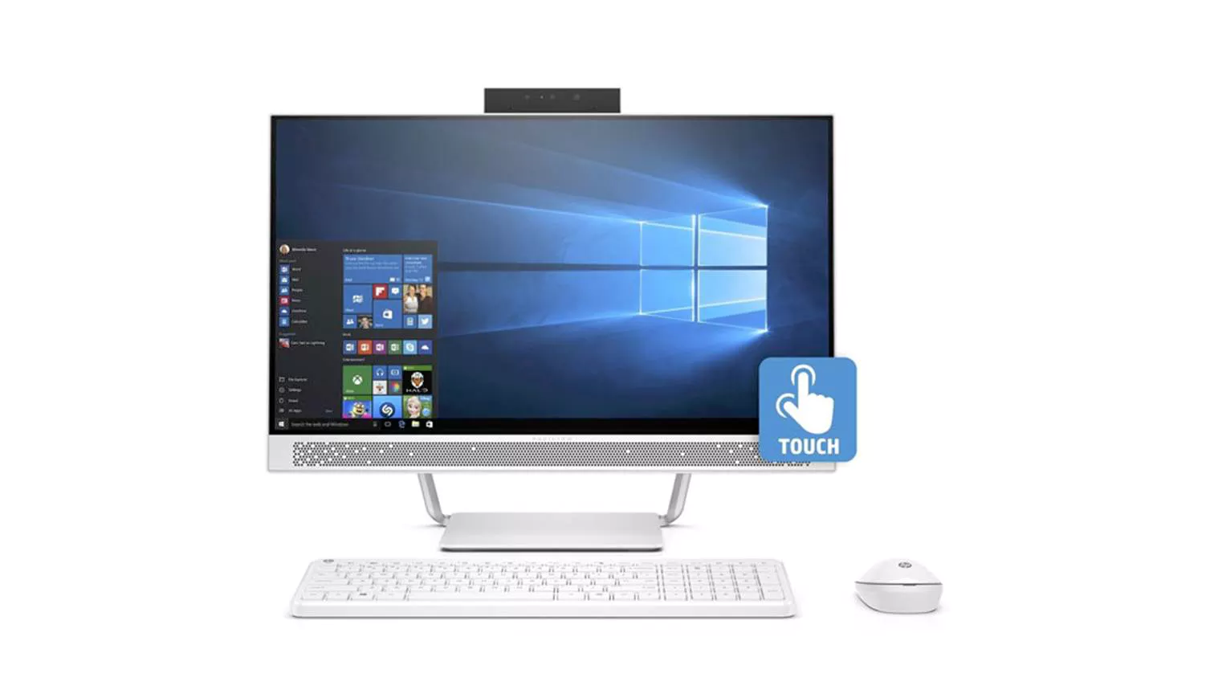

(Image Source: <https://hnsgsfp.imgix.net/4/images/detailed/27/HPPavilion24W10AllInOneDesktopPC.jpg?fit=fill&bg=0FFF&w=1512&h=869&auto=format,compress> )

## Development Constraints (Shawn)

*[List any constraints that are given during the development of the system. (e.g. schedule, platform, etc.). ]*

* Project Deadlines set by the company are hard to meet
* Project budget and venture capital available to our project development team is limited, thereby limiting our project
* The limited number of staff available to work on this project development segment
* Limited computer memory, processing power and hard disk space available
* Limited Software development platforms provided by Mr Wang’s company
* Scope of project development is vague and therefore is not specific
* Project development schedule is demanding and hard to meet
* Enhancing the scope of the project development can be a costly venture as it may be time consuming and expensive
* Incremental software development requirements from stakeholders can become demanding and difficult to implement
* Not knowing the purpose and the usefulness of your software that is in development due to lack of stakeholder feedback
* Operating environment provided by Mr Wang is limited
* The process of interfacing with other systems is a complex process

## Performance

*[List the acceptable system response time for each function during time of operations; on the average and during peak hours.]*

Room Availability and Booking Module

* During peak period
  + The acceptable response time during each page of booking module should be between 1-2 seconds. This is because during peak period the booking system would have multiple staffs booking and checking out customers from their rooms at the same time. Which may cause lag and delay to the system and thus reducing quick response time.
  + The acceptable response time for checking the availability of the rooms should be between 1.5 – 2.5 seconds. This is because the system is constantly updating the room’s information and status to show if it is occupied, vacant, or vacant and scheduled for cleaning. Thus the response time of the system would slow down.
* During off-peak period (average time)
  + The acceptable response time for booking module should be between 0.75-1 second on the average. During off-peak period the system would have less traffic and delay and thus the appropriate response time should be quicker.
  + The acceptable response time for checking the availability of the rooms should be between 0.75-1 seconds. During off-peak period the system should have lesser updating on the room availability thus loading the screen would take lesser time on the average than peak period.

Housekeeping and Staff Management Module

* The acceptable response time for the module should be between 0.75-1 second. Management users will need the module to prepare the daily work schedule for the hotel’s staffs depending on the hotel’s need. The module needs to be able to respond quickly so that the manager will be able to work more efficiently.

Reporting Module

* The acceptable response time for the all functions of the reporting module should be between 0.75-1 second. There are barely any factors that may affect the response time of the reporting module, thus the acceptable response time should be fast and not experience much delay.

User Account and Login Creation Module

* The acceptable response time for creating new user and staff account should be between 0.75-1 second. Unless the database or web server has problems, the response time shouldn’t be slow.

Additional Feature: Online Booking Module

* The acceptable response time for updating the online booking module to view booking information already stipulated above should be around and between 0.75-1 second. Unless there is a high volume of traffic of online bookings being made at a specific time, the response time should not be slow or laggy.

## Availability

*[State the system availability requirements e.g. the system is required to run 24 by 7 or the system is required to run during normal working hours (8am to 6pm) from Monday to Friday. State also the acceptable downtime for maintenance and data backup. For example, 2 hours per week. ]*

The Delonix Hotel system is required to run 24 hours as it is beneficial to both the employees and customers. In the customer's perspective, customers are able to make or manage their reservation any time with ease. As such, this can be an advantage to tourist and foreigners who have landed in Singapore during midnight as they can easily use the Delonix Hotel system to make a reservation. Moreover, this 24 hour system serve as a professionalism tool.

For the employees perspective, they are able to use the system to check on their working schedule as well as their monthly salary at any time. They can also use this system to check on rooms that require repairs or guest request.

As for Mr and Mrs Wang, the Hotel will always be ongoing operations 24/7. Therefore, making the system run 24/7 will allow them to log in to the system at any preferred time to input any required data or information into the system as well as amending their reports.

The preferred time for backup and maintenance will be at 2am-4am, during the non-peak hours. Furthermore, the backup will be once a month on the first sunday of every month.

## Security and Access Control Requirements

*[Specify the user groups that can have access to the respective functions and the user locations (if this is a distributed system). Specify user authority to facilitate control over system access and data access. Identify any log required for audit purpose. List any other security requirements such as data encryption or authentication. ]*

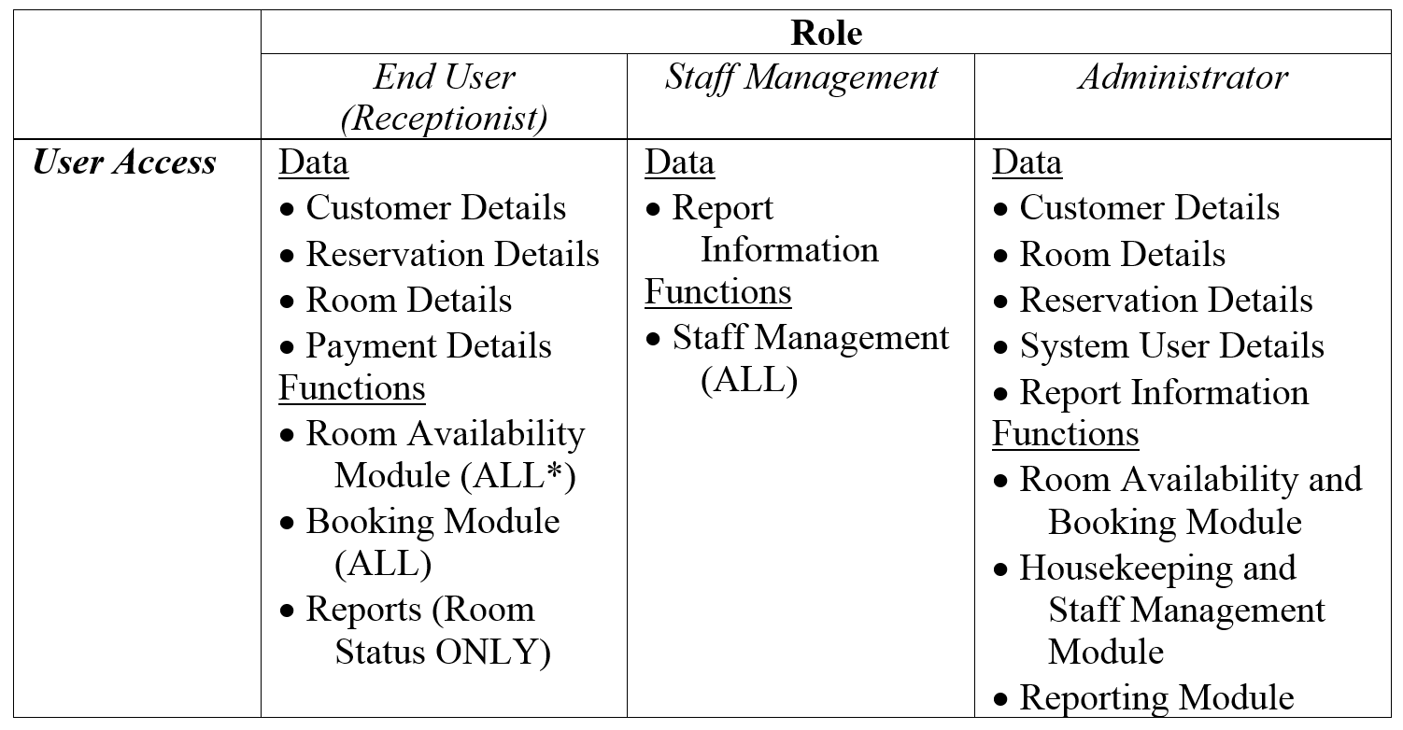

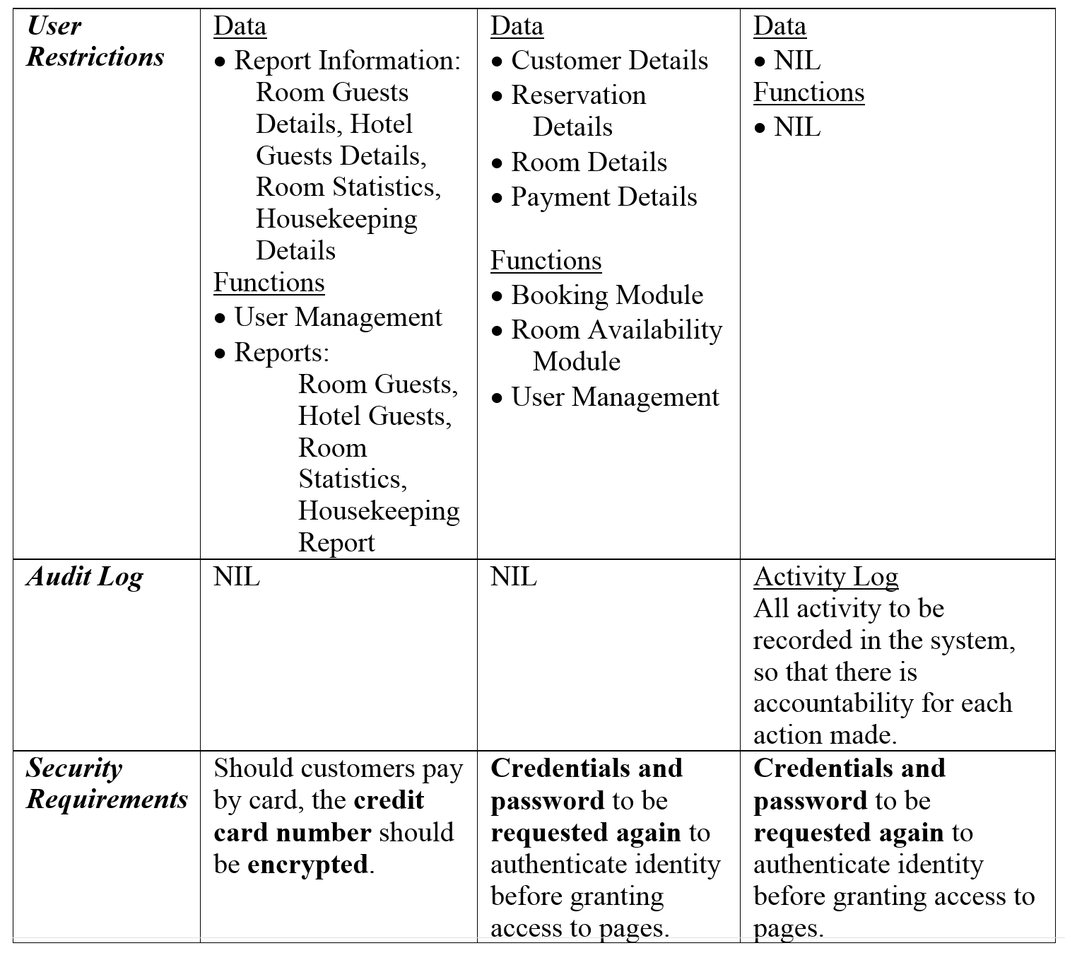

*\*\* ALL indicates the four sub-functions: Create, Retrieve, Update and Delete.*

# SPECIAL REQUIREMENTS

*[Any other requirements that are not included in the above headings, like data archival, etc.]*

Requirements that are not of priority but may want to be implemented in the future or long term:

* Guest being able to enquiry about room availability – this is because Mr Wang is currently communicating with his guests/customers through email, which he has to check with the system to see what rooms are available and replying them afterwards.
* Reporting module should be able to export reports to excel.

Data backups

* Mr Wang requested that data backups should be done only during non-peak hours at 2-3am, and once a month on the first Sunday of every month – Hotel operates 24 hours whole year round where the hotel does not shut down unless it is for major renovations.
* Backup should be kept in system for five years which then can be safely disposed.

# REFERENCES

*[List any books or web site that you have used when preparing this requirement specification.]*

HP Pavilion 24-A251D i5 W10 All In One Desktop PC. (n.d.). Retrieved from

<http://www.harveynorman.com.sg/computers-tablets-and-gaming/computers/desktops/hp-pc-24-a251d-z8g36aa-i5-t.html>

Branscombe, M. (2015, October 20). 20 smart new and improved features in Windows 10 [It's more than just a new name]. Retrieved from

<http://www.techradar.com/news/software/operating-systems/10-great-new-features-in-windows-10-1267365>

MySQL Enterprise Edition: Workbench. (n.d.). Retrieved from

<https://www.mysql.com/products/workbench/>

MySQL Workbench Features. (n.d.). Retrieved from

<https://www.mysql.com/products/workbench/features.html>

MySQL Workbench: SQL Development. (n.d.). Retrieved from

<https://www.mysql.com/products/workbench/dev/>

Hotel Booking Engine Design. (n.d.). Retrieved from

<http://www.edreamhotels.com/hotel-booking-engine/hotel-booking-engine-design/>

Kelly, B. (n.d.). The Role of a Manager in Housekeeping In the Hotel Industry. Retrieved

from <http://work.chron.com/role-manager-housekeeping-hotel-industry-22124.html>